Characterizing the legacy of emerald ash borer on ash populations near the epicenter of invasion in North America: Project Update – January 2025

Emerald ash borer (Agrilus planipennis, EAB) was accidentally introduced to North America in the 1990s and continues to spread across the US and Canada. Swamps in the northern US are threatened, due to black ash’s (Fraxinus nigra) susceptibility to EAB-induced mortality and the high abundance of black ash in floodplains and depressional swamp forests. Whether or not ash trees are extirpated from natural forests depends on whether ash regeneration can grow large enough to produce viable seeds before being killed.
We used pre-existing forest plots located in Oakland and Washtenaw Counties, Michigan, to study the long-term fate of ash regeneration. Thirty-seven transects were established and surveyed between 2004 and 2008, when EAB was initially beginning to kill canopy ash. Each transect was classified based on soil moisture into three categories: hydric, mesic, or xeric, which also corresponded to the predominate ash species: black ash, green ash, or white ash. We sought to compare the occurrence and health of ash trees in these transects which vary in soil moisture level. Given the understanding of ash tree reproduction, we expected newly germinated ash seedlings to be absent, which would be consistent with a lack of seed-producing ash trees in 2024. Furthermore, we hypothesized that larger ash trees would have a higher prevalence of EAB symptoms, consistent with previous studies. Furthermore, we attempted to characterize the abundance of EAB in these aftermath forests and investigate if introduced parasitoid wasps of EAB are present at the transects. Although introduced parasitoids are not able to prevent canopy ash mortality, we hypothesized that the parasitoids could limit the population of EAB enough to allow smaller ash trees to reach reproductive age before being killed.
A
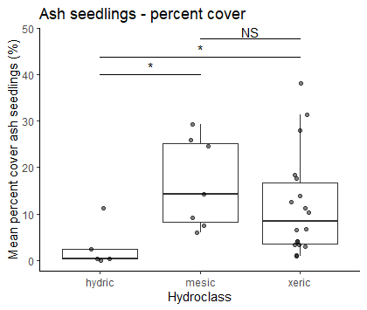
Preliminary results:
We have relocated and surveyed ash regeneration in 97 out of 111 plots (there are 3 plots per transect) and intend to complete the dataset by Fall 2025.

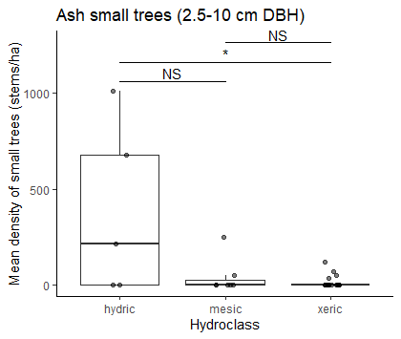
We found regenerating ash in transects of all soil moisture classes (hydric, mesic, and xeric), but the size of ash regeneration varied by soil moisture class. In mesic riparian and drier xeric transects, ash regeneration largely remained at the seedling (0-137 cm height) or sapling (< 2.5 cm DBH) level. In contrast, some hydric transects had more small ash trees in the 2.5-10 cm DBH range, but lower numbers of ash seedlings than drier forests (Fig. 1).
B

Newly germinated seedlings (those with cotyledons) were not found in 2024 despite extensive counting of ash seedlings. However, a few ash trees were found to be producing seeds, including black ash trees at Proud Lake Recreation Area and Indian Springs Metropark.

For each of the ash trees ≥ 2.5 cm in our transects, we recorded signs and symptoms of EAB attack, such as canopy leaf defoliation and the production of epicormic sprouts from the trunk due to vascular system stress. Our models show that the presence of EAB symptoms and canopy decline generally increases from 2.5 cm DBH to around 9 cm DBH (Fig. 2A). However, of the small number of trees above 10 cm DBH, a higher proportion appear to be healthy. Although a large fraction of black ash trees are declining, there are some in the 7.5 -10 cm range which remain healthy (Fig. 2B).
Figure 1. Occurrence of ash in 30 transects varying in soil moisture class (x-axis). A) Average % cover of ash seedlings (0-137 cm tall). B) Average stem density of small ash trees (2.5-10 cm DBH)

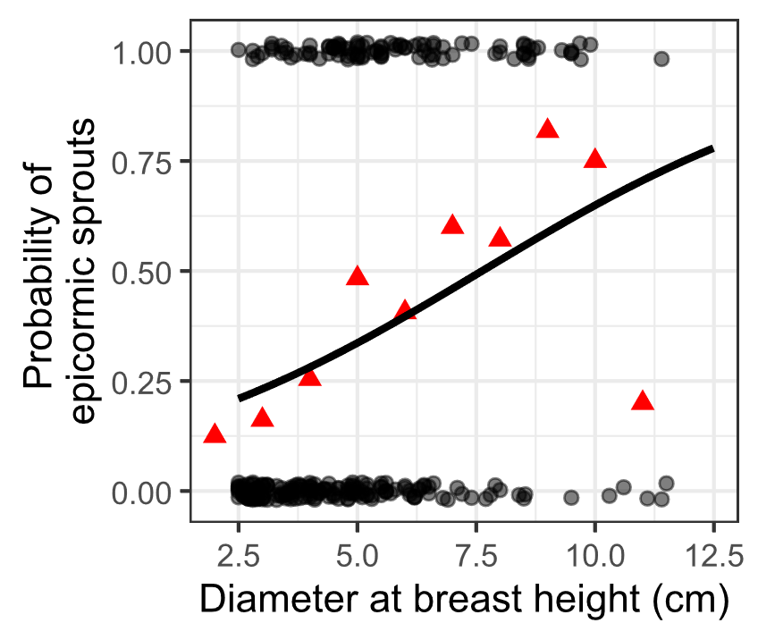
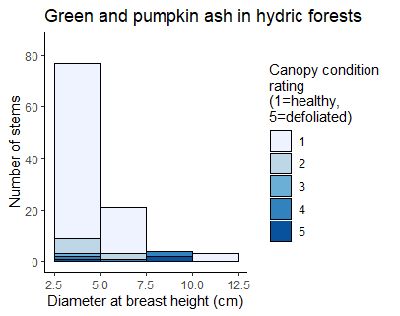
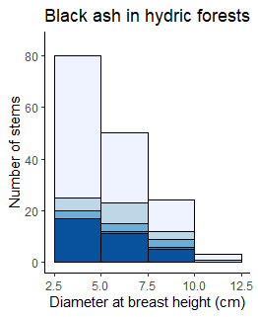
Figure 2. Health of ash trees in transects in the Upper Huron River Watershed. A) The y-axis represents the presence (1) or absence (0) of epicormic sprouts on the trunk, a symptom of EAB. The black line is the fit for a binomial generalized linear mixed-effects model with DBH as fixed effect and plot as random effect. Red triangles indicate means of groups binned by DBH. The sample size is 272 trees located in 6 hydric and 1 mesic transect. B) Histogram of black ash (Fraxinus nigra). Shading represents the proportion of each size class with each canopy condition rating, with darker shades indicating more canopy decline. C) Same graph for green ash (Fraxinus pennsylvanica) and possibly pumpkin ash (Fraxinus profunda), which were not separated during species identifications.
A
C
B

Future work:
Taken together, our preliminary results suggest that, within our study transects, ash in hydric forests have come closer to regaining their position as mature trees, while ash in mesic and xeric forests remain at the seedling or sapling level. In summer 2025, we hope to investigate the response of non-ash trees in hydric forests to EAB-induced ash mortality. We hypothesize that the increase in soil moisture during canopy ash mortality, coupled with the already challenging edaphic conditions in hydric transects, limited the ability for non-ash canopy trees to increase their growth rate. Instead, we hypothesize that either black ash regeneration expanded into the space previously occupied by canopy ash, or that herbaceous vegetation and shrubs took the place of canopy ash in hydric forests.

